**AUTO MESSAGE APPLICATION - CONNECTFOR**

**A Complete Guide on how to Run the Application**

**By: Vidit Vaywala and Varshil Shah**

**Mentors: Ms. Vidhi Ghia and Ms. Gargi Modi**

**Steps for Downloading the Application**

* The application can be downloaded from the google drive link mentioned below.
* <https://drive.google.com/drive/folders/1GxwHv6wqi6aOAXJNM7FckwsPrBhpFyqX?usp=sharing>
* The application contains all the dependencies installed and hence the size of the application is around 370 MB.

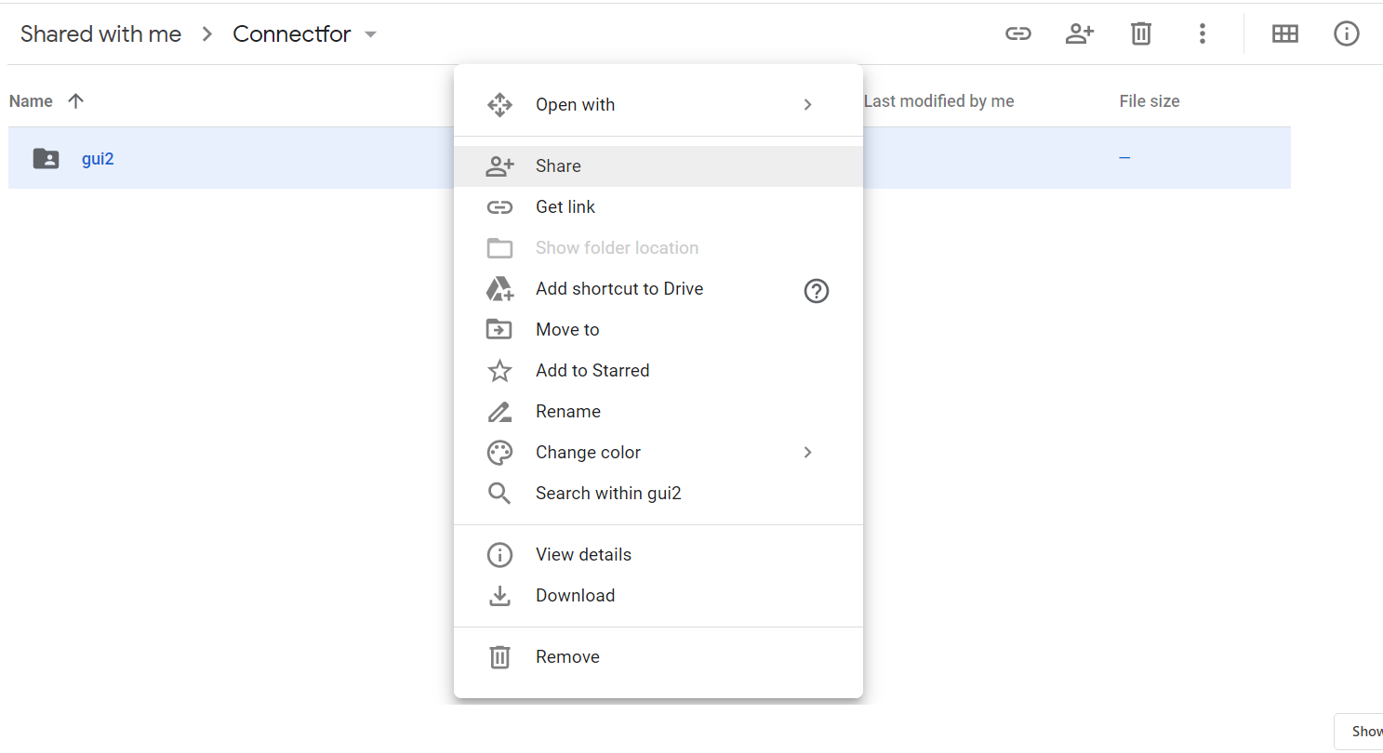

* Once you open the link, you will be redirected to a folder named “**Connectfor”** inside the google drive. Go inside the Connectfor folder where you will find another folder named **“gui2”.** Right-click on the gui2 folder and click the download button as shown in the above image to download the application.
* Google Drive will initially start to zip your file and you will see a message saying “**1 file zipping**” at the bottom right area of your screen.
* Once your file is zipped, you will see a “**leave or cancel**” pop-up at the top of your screen as shown in the below image.

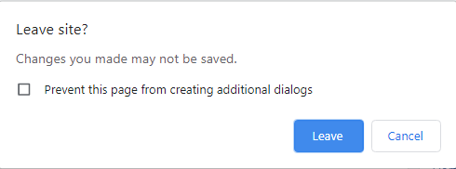

* Please click on the “**leave**” button and your download will start. Wait for your download to complete and follow the next steps mentioned below.

**Steps to install the downloaded application on your PC/Laptop**

* Go to the folder where you downloaded the zip file following the above steps. (In most laptops, the downloads are reflected in the “**downloads**” folder in your computer).
* Once you are there, right-click on the zip file and click on extract here or extract files depending on which place on your computer you want to save the extracted folder. (After right-clicking you should see an output similar to that shown in the below image).

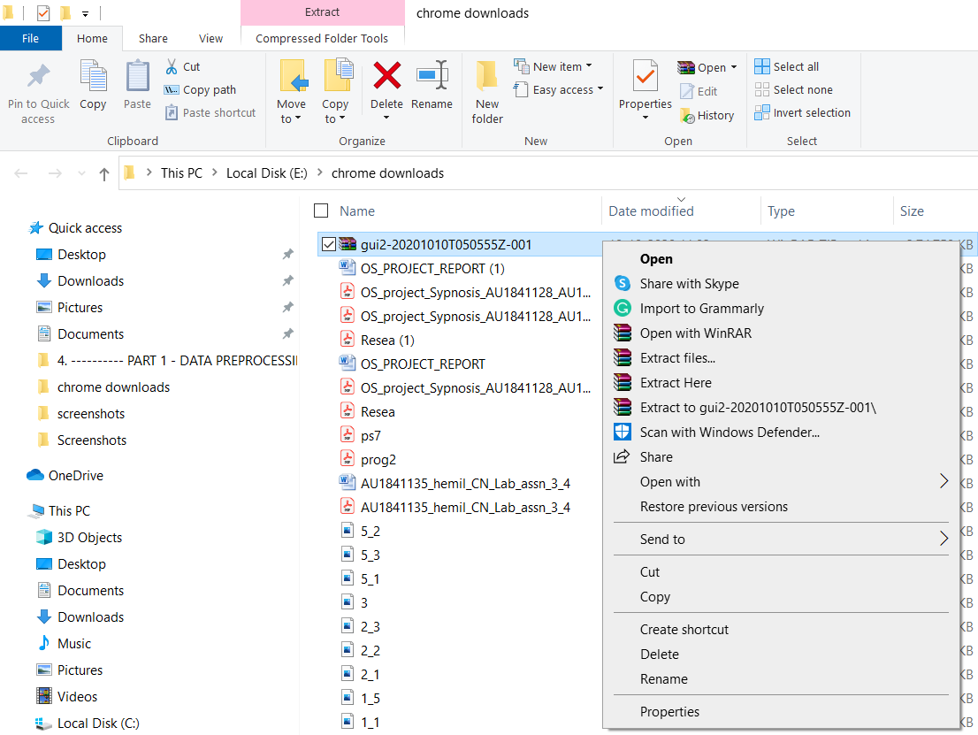

* Once you extract the folder, go inside it and you will see a list of folders and files as shown in the below image.

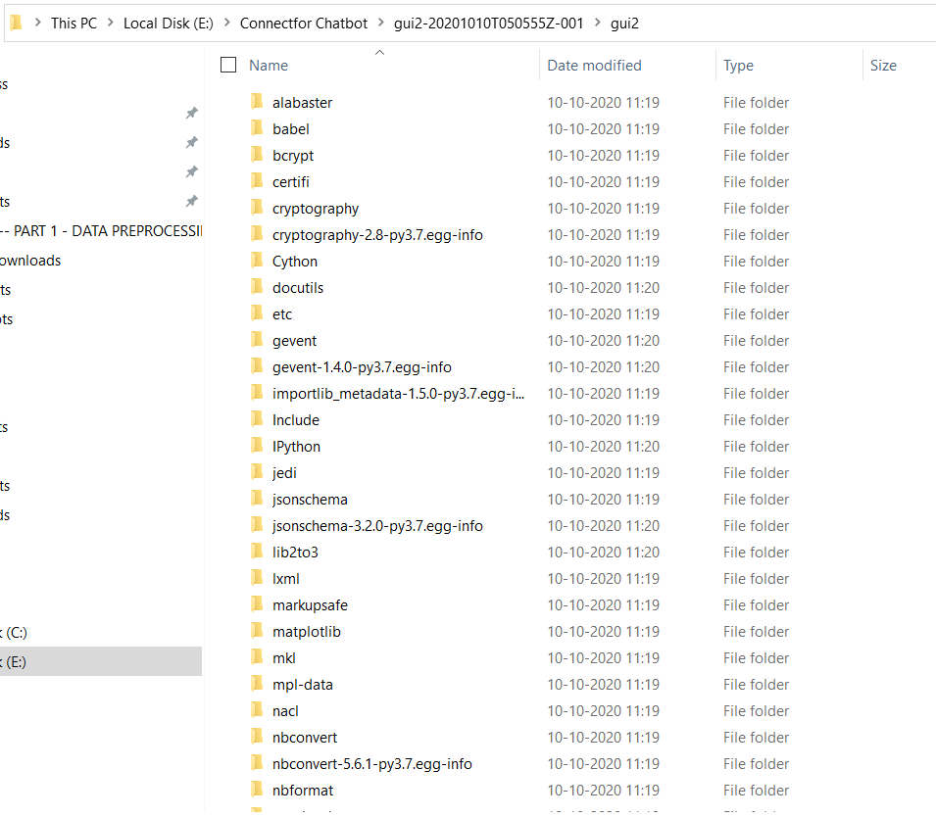

* If you are able to see the above output then congratulations! You have successfully downloaded the application and are ready to run it. Please follow the next set of steps in order to run the application successfully.

**Steps to Download the Chrome Driver**

* In order to run our application, we would need to download a software called **Chrome Driver** which is the automated software that controls your google chrome. (Note: You would need Google Chrome to run this application).
* <https://chromedriver.chromium.org/downloads>
* Go to the above link and check out the section of “**Current Releases”.** You will find different versions of Chrome Driver for different versions of google chrome.
* The next step is to check your version of Google Chrome in order to download the correct Chrome driver.
* To check the version of your google chrome, click on the 3 dots on the top right of your google chrome tab, below the close button.
* After clicking the 3 dots, go to the settings tab.

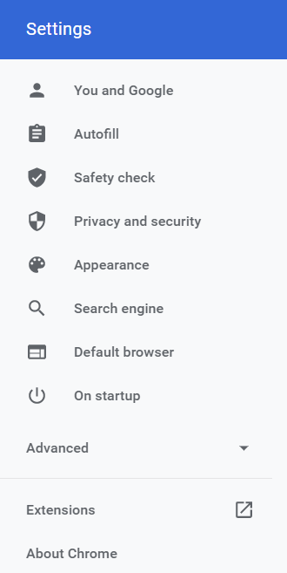

* You will see the above output in the settings section. Click on “**About Chrome**” mentioned at the bottom in order to check your version. You will find the below output with the version of your google chrome.

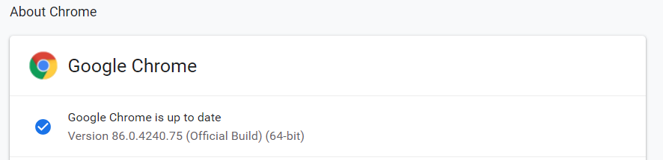

* Once you know the version of your google chrome, again go to <https://chromedriver.chromium.org/downloads> , and download the google chrome according to your version.

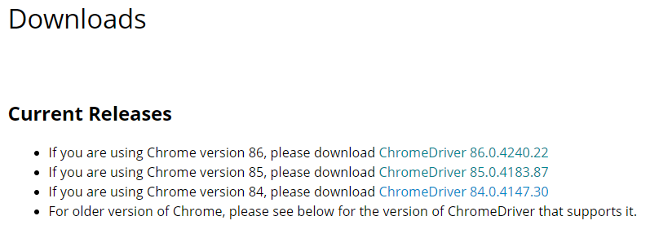

* For this example, the version of the google chrome is 86.0.4240.22 hence we will click on that link to download the Chrome Driver. Once you click on one of the above links, you will see an output as shown in the image below.

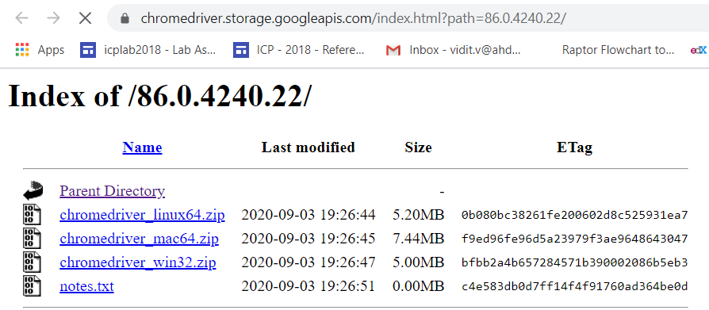

* Download the chrome driver according to your system. If you are using linux system then click on the link ending with “**_linux64” ,** If your system is mac system then click on the link ending with “**_mac64” ,** and if you are using windows (any of the two- 32 bit or 64 bit) then click on the link ending with “**_win32”.**
* **Note: This application will only work on Windows system and not on Linux or Mac systems.**
* Once your download completes, you will find a zip file in your computer with the name “**chromedriver_win32/mac64/linux64**”. Extract this zip file (in order to know how to extract a zip file, please refer to the 1st section of this document) and you will see a folder named “**chromedriver_win32/mac64/linux64”** created on your system.
* Go inside the folder and you will find a file with the name **“chromedriver”** as shown in the image below.



* Copy this file and move it to our “**gui2”** folder where all other files of our chatbot are stored. The **“gui2”** folder can be navigated from the second section **“Steps to install the Downloaded Application”**.
* Paste the chromedriver file into the gui2 folder. Now we have completed the setup process and are ready to run the application. Please refer to the next section in order to know how to run our application.

**Steps to run the application and send messages**

* Go into the **gui2** folder and find a file named **gui2.** The file has Connectfor’s logo in the icon so it will be easy to find. It looks like as shown in the below image.



* Double click on the file to run it. You will see two screens popping up. One is a black coloured screen called command prompt and other is a grey coloured screen of our application. Please wait patiently as it may take around 1-2 minutes for both the screens to load. The expected output is shown in the below image.

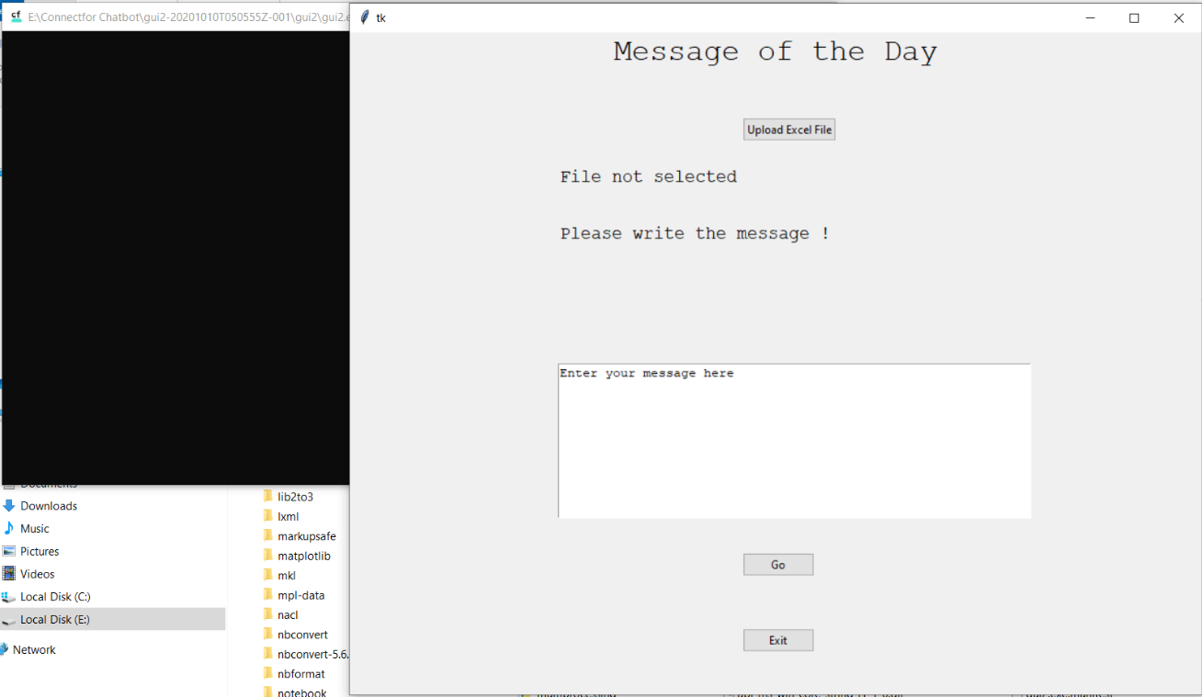

* The next step is very important. We need to upload an excel (**.xlsx**) file in a specific format. The cell “A1” should contain the word **“Name”** with N capital. And the cell B1 should contain the word **“Number”** with N capital again. Then you can start adding the corresponding names and number from the cell A2 and B2 respectively.
* The format of the number should strictly be **“91xxxxxxxxxx”.** No “+” sign required at the beginning. The number should always have **91** as the prefix.
* **Note:** Once you enter the number in the excel file, it will convert it to scientific notation (as shown in the image below). That is completely fine and should not be misunderstood as an error.

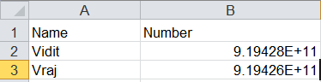

* In order to download a sample file, please click on this link: <https://drive.google.com/file/d/1N1WQADN4-qyziSjd2F0AjJFRgVeqjYZ3/view?usp=sharing>
* So after getting the format right and inserting the names and number of all the people you want to send the message to, you are ready with your excel file. Let us now continue the steps towards running the application.
* So once you are in the application, you will see a button titled **“Upload Excel File”.** Click on that button and upload your desired excel file. You will see an output as shown below.

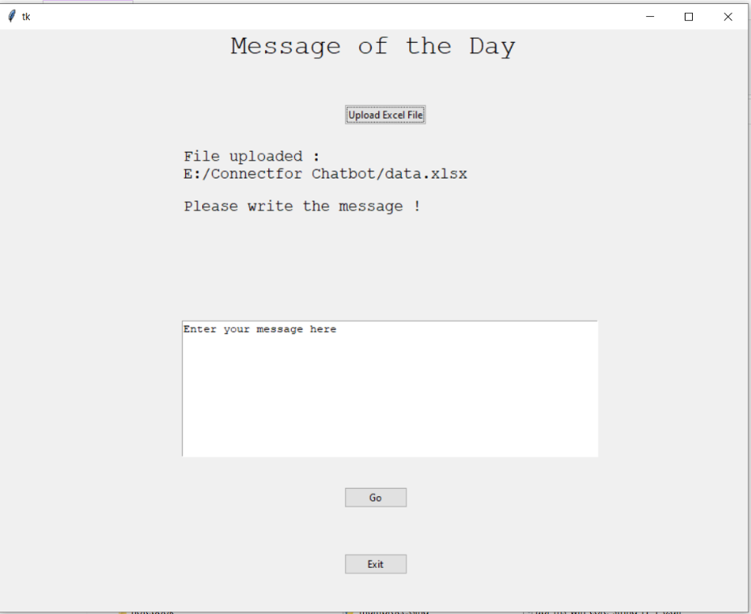

* The next step is to write your message in the white box that says “**Enter your message here”.** You can write your entire message in that box with proper formatting (Spacing, new line, etc.) and also include any links or URLs if you want. Once your message is entered, press the **“Go”** button and after a few moments a new google chrome tab will open and your WhatsApp web will start loading as shown below.

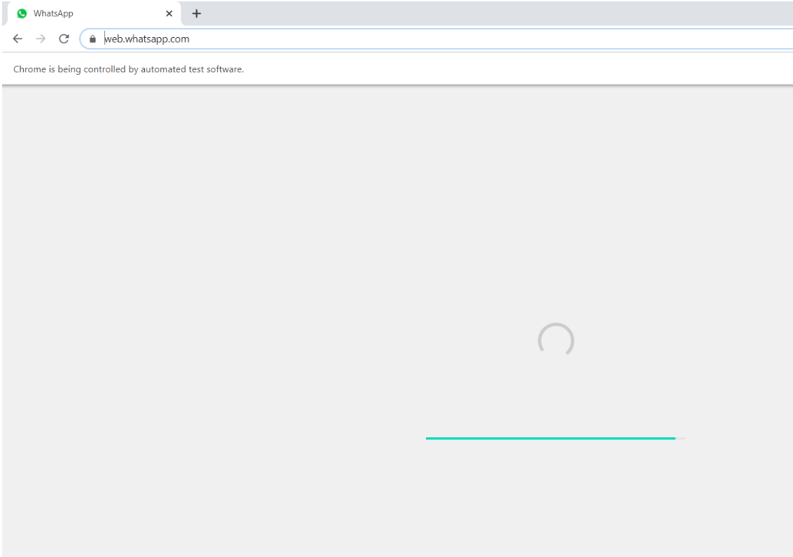

* When you run the application for the first time, your WhatsApp will ask for “**login**” and you would need to login to your WhatsApp web. Once logged in, it will start loading again and would send the message to the first contact mentioned in your excel sheet. The output is shown below.

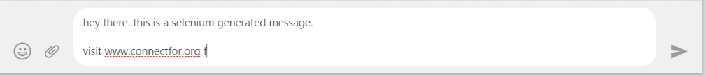

* Chrome is typing the above message on its own and will send it on its own to the contact. Once the message is sent to the first contact, chrome will load the WhatsApp web again till its searching for the second contact. You will again see the following screen.



* After loading, it will go into the screen of the second contact and again start typing the message again on its own. Then it will again load and again type. It will follow this cycle until it has sent the message to all the contacts in the excel sheet that you uploaded.
* Note: The maximum number of contacts that it can send upto in one go is **100 (provided with a fast network).**
* Once the message is sent to all the contacts, you will see the following output on the Command prompt screen (The black screen) that is open in the background. Please refer to the following image.

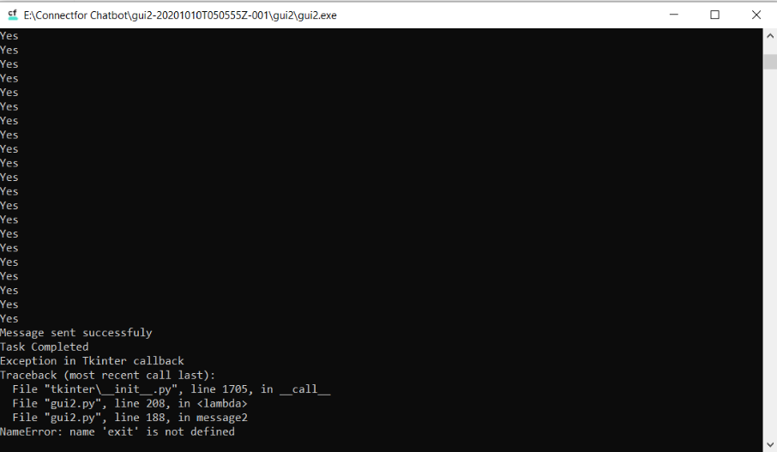

* On the application screen (the grey screen), you will see a popup that asks you “**send again?**” if you want to send the same message to all the contacts again then press yes otherwise press no. Check out the image below.

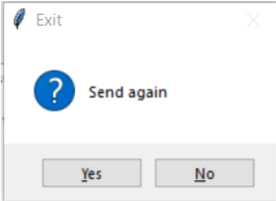

* After that press on the **“Exit”** button on the application screen (The grey screen) in order to exit the application.
* In this entire process, some errors may happen sometime due to incorrect execution or less internet stability. Please refer to the next section in order to see the common errors that can happen and how to resolve them.

**Common Errors encountered and how to resolve them**

* The most common error you would encounter during the execution of this programme would be because of “Internet Instability” or less Internet speed.
* You would most likely see any of the following images if an error occurs in the program or internet fluctuations happen.

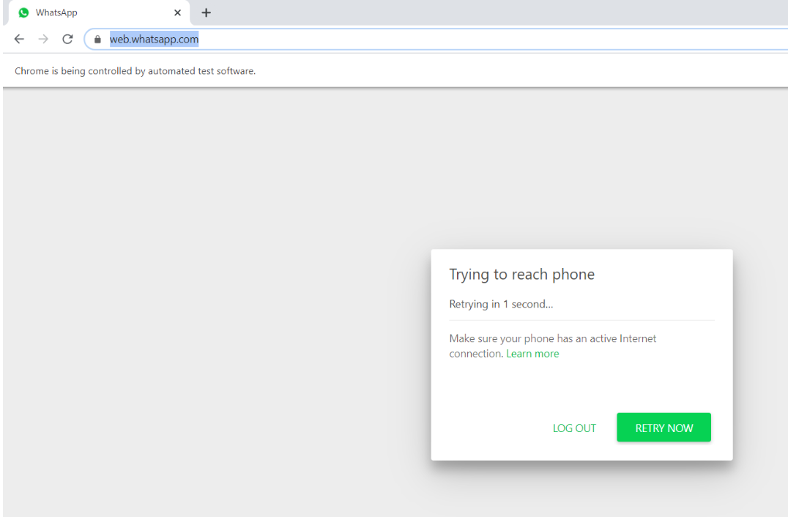

In the above image, your WhatsApp web is having trouble connecting. You can press “**retry now**” after checking your internet connection.

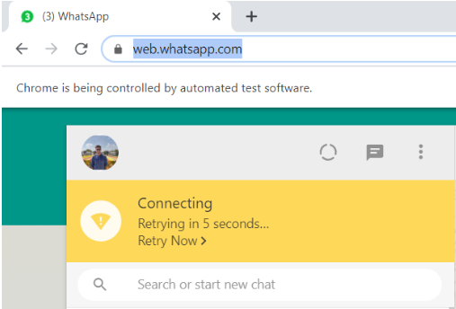

Sometimes you will see the above image when your WhatsApp web is again trying to connect. If this happens, then please wait for 5 10 seconds for this yellow box to disappear. If it doesn’t disappear within some time then click on retry now and wait again.

* Even after clicking “**retry now**”, if your whatsapp web is not open then close that google chrome tab, close the application by clicking **“exit”** or the **X** button at the top and rerun the application after checking your internet connection.

**Note: The auto-message application will be running in one window of Google Chrome. You cannot click on the + icon and open another tab in that same google chrome window. If you want to use Google Chrome during the message sending process, please open a new window of google chrome and work over there.**

**We have mentioned the common errors that we encountered while running the application on our laptop above. If you encounter any more errors or if the application is not running properly, please take relevant screenshots and mail it to us on the below given details. You can also WhatsApp us the relevant images along with the problem that you are facing and we will get back to you as soon as we can.**

**Contact Details**

* Varshil Shah

Email: [varshil.s@ahduni.edu.in](mailto:varshil.s@ahduni.edu.in) or [shahvarshil@yahoo.com](mailto:shahvarshil@yahoo.com)

Mobile number: +918980190408

* Vidit Vaywala

Email: [vaywalavidit267@gmail.com](mailto:vaywalavidit267@gmail.com) or [viditvaywala267@gmail.com](mailto:viditvaywala267@gmail.com)

Mobile Number: +919427974782